BWC ENTRY FORM
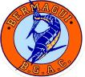
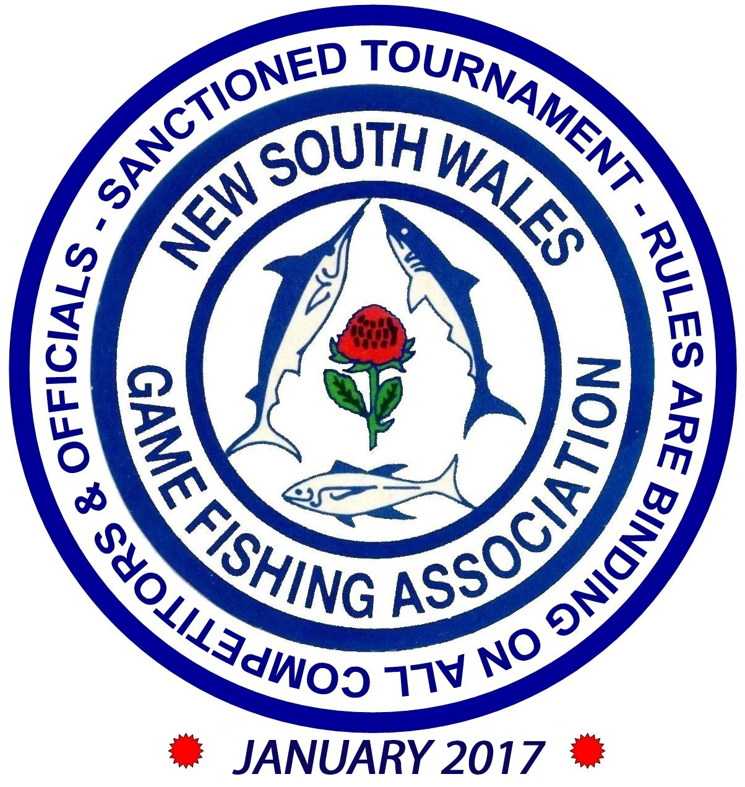
THE BERMAGUI BIG GAME ANGLERS CLUB PRESENT SHIMANO Bermagui Bait & Tackle BLUE WATER CLASSIC HELD OUT OF THE HISTORIC PORT OF BERMAGUI BETWEEN 27, 28 and 29 JANUARY 2017 OFFICIAL ENTRY FORM
BOAT NAME ______________________________________________

TEAM INFORMATION

SURNAME | FIRST NAME | M/F/J/SF | CLUB | COMP T SHIRT SIZE S, M, L, XL, XXL, 3XL,4XL, 5XL
Only members affiliated with GFAA or overseas visitors affiliated with IGFA can fish this tournament

Only members affiliated with GFAA or overseas visitors affiliated with IGFA can fish this tournament

TOURNAMENT ENTRY FEES

TOURNAMENT ENTRY FEES
Adults (includes free tournament T shirt & BBQ) No._______ At $ 110 $ _________
Early Entry Fee—Adults (payment to be received by 24th January No._______ At $95 $ _________
Juniors 11 - 16 (includes free tournament t shirt & BQ) No._______ At $ 50 $ _________
Small Fry (includes free tournament t shirt & BBQ) No._______ At $ 30 $ ________
Tournament Temp Membership No._______ At $ 50 $ ________
Presentation dinner tickets No._______ At $ 45 $ ________
BBQ (extras) No._______ At $ 15 $ ________
Total $ __________
Captain’s Postal Address
Captain’s Home Phone Number Phone Number During Tournament ____ _
Captain’s Address During Tournament
Please complete the information / safety checklist on the reverse and return with the appropriate fees to:
THE SECRETARY BERMAGUI BIG GAME ANGLERS CLUB PO BOX 52, BERMAGUI NSW 2546 Ron De La Mare 0428 244 955 Cassie Schofield 0427 962 379 EMAIL : bbgacbwc@gmail.com

Adults (includes free tournament T shirt & BBQ) No._______ At $ 110 $ _________

Early Entry Fee—Adults (payment to be received by 25th January) No._______ At $95 $ __________

Juniors 11 - 16 (includes free tournament t shirt & BQ) No._______ At $ 50 $ _________

Small Fry (includes free tournament t shirt & BBQ) No._______ At $ 30 $ _________

Tournament Temp Membership No._______ At $ 50 $ _________

Presentation dinner tickets No._______ At $ 45 $ _________

BBQ (extras) No._______ At $ 15 $ _________
Total $ __________

Captain’s Postal Address
Captain’s Home Phone Number Phone Number During Tournament _____
Captain’s Address During Tournament
Please complete the information / safety checklist on the reverse and return with the appropriate fees to:
THE SECRETARY BERMAGUI BIG GAME ANGLERS CLUB
PO BOX 52, BERMAGUI NSW 2546
Ron De La Mare 0428 244 955 Cassie Schofield 0427 962 379
EMAIL : bbgac@bigpond.com

Adults (includes free tournament T shirt & BBQ) No._______ At $ 110 $ _________

Early Entry Fee—Adults (payment to be received by 25th January) No._______ At $95 $ __________

Juniors 11 - 16 (includes free tournament t shirt & BQ) No._______ At $ 50 $ _________

Small Fry (includes free tournament t shirt & BBQ) No._______ At $ 30 $ _________

Tournament Temp Membership No._______ At $ 50 $ _________

Presentation dinner tickets No._______ At $ 45 $ _________

BBQ (extras) No._______ At $ 15 $ _________
Total $ __________

Captain’s Postal Address
Captain’s Home Phone Number Phone Number During Tournament _____
Captain’s Address During Tournament
Please complete the information / safety checklist on the reverse and return with the appropriate fees to:
THE SECRETARY BERMAGUI BIG GAME ANGLERS CLUB
PO BOX 52, BERMAGUI NSW 2546
Ron De La Mare 0428 244 955 Cassie Schofield 0427 962 379
EMAIL : bbgac@bigpond.com

BOAT INFORMATION
[To be completed by the Team Captain]
Name of Vessel Reg No
Make of Vessel Length metres
Type: Full Cabin Half Cabin Other
Colour: Hull Topside
Number of Engines Fuel Type
Make of Engine/s Horsepower
Vehicle Registration Trailer Registration
Radio Equipment: 27MHz 2Meg VHF
Navigational Equipment: Radar Depth Sounder GPS
On Board Mobile Phone Number (please leave mobile phones switched on)
All craft must comply with minimum N.S.W.M.S.B. safety requirements and must be equipped with the minimum radio channels 27.88 MHz, 27.94 MHz and 27.96 MHz

SAFETY CHECKLIST

❑ Bailing Bucket  Flares – Parachute  Emergency Rations  Flares – 2 Orange Smoke  Fresh Water (2litres per person)  Flares – 2 Red Star  Sea Anchor  E.P.I.R.B.  Distress V Sheet  Fire Extinguisher  Reflective Mirror  Life Jackets (1 per person)  Paddle (single engine boat)

INSURANCE DETAILS

INSURANCE DETAILS

Name of Insurer Policy No.
Renewal Date
NB: A copy of your policy or evidence thereof MUST accompany your entry.
 My crew and I agree to abide by the rules of the tournament and understand that any clarification requested will be provided by the tournament committee at the the holding of this tournament is not to be construed as an invitation to go to sea in conditions beyond the capability of craft and crew.

Signed – Team Captain
Skippers Email Address:
Name of Insurer Policy No.
Renewal Date
NB: A copy of your policy or evidence thereof MUST accompany your entry.
My crew and I agree to abide by the rules of the tournament and understand that any clarification requested will be provided by the tournament committee at the tournament briefing. In addition we agree that participation is at own risk and that the holding of this tournament is not to be construed as an invitation to go to sea in conditions beyond the capability of craft and crew.

Signed – Team Captain

Skippers Email Address:
❑ Bailing Bucket  Flares – Parachute  Emergency Rations  Flares – 2 Orange Smoke  Fresh Water (2litres per person)  Flares – 2 Red Star  Sea Anchor  E.P.I.R.B.  Distress V Sheet  Fire Extinguisher  Reflective Mirror  Life Jackets (1 per person)  Paddle (single engine boat)
❑ Bailing Bucket  Flares – Parachute  Emergency Rations  Flares – 2 Orange Smoke  Fresh Water (2litres per person)  Flares – 2 Red Star  Sea Anchor  E.P.I.R.B.  Distress V Sheet  Fire Extinguisher  Reflective Mirror  Life Jackets (1 per person)  Paddle (single engine boat)
❑ Bailing Bucket  Flares – Parachute  Emergency Rations  Flares – 2 Orange Smoke  Fresh Water (2litres per person)  Flares – 2 Red Star  Sea Anchor  E.P.I.R.B.  Distress V Sheet  Fire Extinguisher  Reflective Mirror  Life Jackets (1 per person)  Paddle (single engine boat)

SAFETY CHECKLIST

SAFETY CHECKLIST

SAFETY CHECKLIST

